Data Analysis Project – GIS Mapping Guidance Sheet (2023/24)

You are tasked with creating an interactive Story Map using ArcGIS Map and Story Map applications. The application will use the data collected from the field trips in Barcelona and London to explore the theme you have been allocated on (i.e., Work, Movement, Identity, or Infrastructure).

Your Story Map application should contain the following design elements:

- The Cover can use be either “Minimal” or “Side-by-side” or “Full” which ever design choice of your preference.

- The header section of your Story Map it must contain a main title, your candidate ID (not your name), and your group number

See example below:

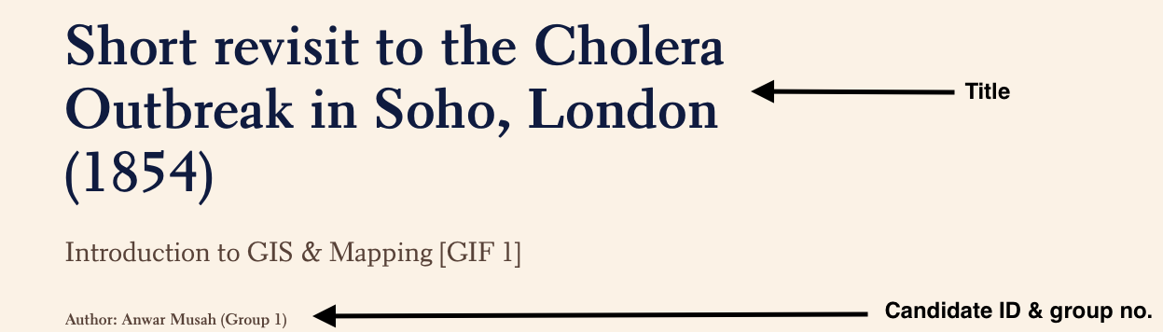

- It should be sectioned at most to three major headings or Content Blocks. If you are using references or other source materials (etc., images or audio) then include them when as section as well.

See example below (which contains 5 major content blocks):

- It should contain one or at most three short, embedded videos (< 1 minute) recorded from the field. This could be a visual of the location, an interview with a friendly or simply the dynamics/atmosphere all within accordance of your theme. You are welcome to submit a ‘shorts’ documentary of your group to support the narrative. Note: You don’t have to physically be in the video if you don’t want to!

- The narrative of the theme for the main body throughout story map should contain maximum of 550 words. It should include the aim of the field activity, description of study area, a brief reflection on research methods and experience.

- It should contain at least five photos to support the narrative of your theme with the appropriate caption or annotation.

- Interactive map should be embedded to your story map application. It must contain the following design features:

  - It must be full functionable with the following features: zoom-in, zoom-out and expand buttons
  - It must contain a key/legends
  - Point locations of interests (i.e., these correspond to the geotagged data collected in Barcelona or London)
  - Point locations must be clickable bringing up a mini-window with lore information, and a picture photo of that point location.
  - Routine data must be shown on the map

Motivating examples:

Work | https://storymaps.arcgis.com/stories/c626a5ec074e45899f695aa05ae171c2
Identify | https://storymaps.arcgis.com/stories/a8871ac74a41485ba9be0ab3da4c0ba9
Movement | https://storymaps.arcgis.com/stories/b109c5401a6340f2be1db20335509d11
Infrastructure | https://storymaps.arcgis.com/stories/0b0b338f9a6f47f7b856034c4d97a869
Cholera | https://storymaps.arcgis.com/stories/d56637a2dea048adbb520082eddea076

The above are good examples. You are allowed a lot of creative freedom to build your own story map with the group field data. Please do not copy any of the text from the above examples or it’s will be an immediate failure if you’re caught.

Once you have finished your work, you must copy and paste the URL of your Story Map on the GEOG0013 Submission Cover Sheet. Please include the following details:

- Exam candidate ID
- URL to Story Map
- Group number

IMPORTANT NOTE:

The deadline for submitting this assignment is 12:00pm on the 8th of December 2023.

The GEOG0013 Submission Cover Sheet Coursework should only be submitted via the Moodle’s Turnitin link. We appreciate the fact that each individual will be using their group data, shared text, images etc., and so maps and content will be somewhat similar, which is okay. Just make sure you create your own Story Map and submit that – you are allowed to work together with your group, but you are also allowed to exercise creative freedom so please vary it up a little.

With that being said, all coursework must be submitted anonymously. The submission title of the GEOG0013 Submission Cover Sheet Coursework word file (.doc or .docx) should be your Exam Candidate ID only.

